Suction Feeding Exercise
Goals:
- Find the volume of the feeding mechanism of the fish at rest.
- Find the volume of the feeding mechanism of the fish at maximum expansion.
- Find the area of the mouth of the fish at maximum expansion.
- Determine the velocity of water flow into the mouth using the formula:

$$velocity=\frac{Change in Volume}{Change in Time}×\frac{1}{Area of Mouth}$$

3-Dimensional Model of the Feeding Mechanism

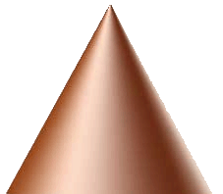
Mouth

3-Dimensional Model of the Feeding Mechanism Broken into Two Parts

B
A
Mouth

2-Dimensional Model of the Feeding Mechanism

A
B
Mouth

2-Dimensional Model of the Feeding Mechanism Broken into Two Parts
(Note: An extension is shown to help you find the area of the truncated cone. )

b
a
c
d
e
a

B
A

a = radius
d = radius
b = length
c = length
e = length

