Name:___________________________________________ Date:______________________ Period________

Understanding Abiogenesis – From Monomers to Polymers - Key

The next step in abiogenesis is the movement from monomers to polymers in order to make molecules that are capable of complex reactions or functions, like information storage for DNA, enzymatic activity for proteins, and energy storage with sugars. These polymers, along with the 4th macromolecule, lipids, make up cells.
Proteins are, arguably, the most important macromolecule. Proteins act as catalysts, pumps, motors, generators, structural elements and more. And all of these are made from the same 20 amino acids. In fact, only these 20 amino acids are found in proteins in all known life, suggesting that all life on this planet shared a common ancestor. The basic amino acid structure has an amino group, a carboxyl group, a functional (R) group, and a hydrogen all connected to a central carbon, as pictured below.
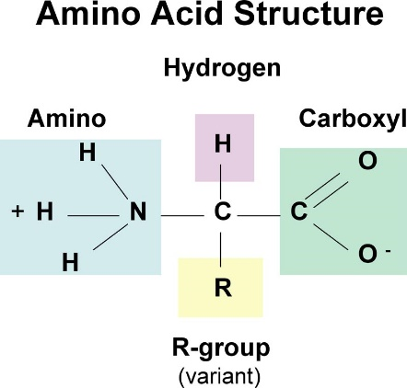

1) Below is the structural representation of 7 amino acids, chosen for both their reasonably small size and for their diversity in nature. Label each part in the amino acid and identify whether the functional group is hydrophobic, hydrophilic, or amphiphilic.
C₅H₁₁NO₂S
Methionine
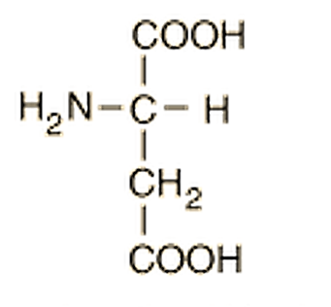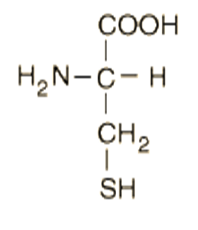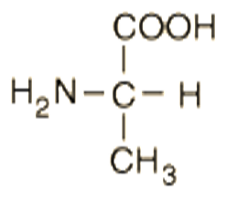
C₄H₇NO₄
Aspartic acid
C₃H₇NO₂S
Cysteine
C₃H₇NO₂
Alanine

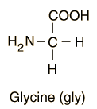nonpolar polar polar
C₂H₅NO₂
Glycine
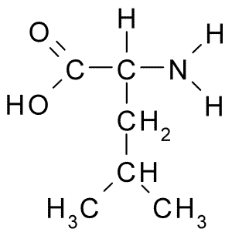
polar
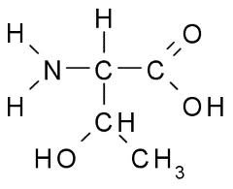

amphiphillic
Threonine C₄H₉NO₃
Leucine C₆H₁₂NO₂

nonpolar polar
2) Amino acids are linked to each other by dehydration (condensation) reactions between the amino group of one amino acid and the carboxyl group of the next, as in the picture below.
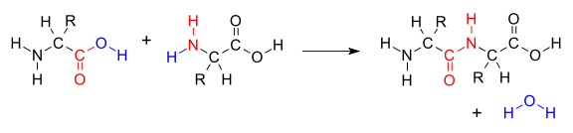
From these reactions, amino acids are bonded together in a chain called a polypeptide.
What are the molecules above called that are made as a result of the condensation/dehydration reaction? Di-peptide and water
As a class, use the molecular kits to assemble a polypeptide chain with the amino acids in this order: Methionine, Alanine, Cysteine, Glycine, Threonine, Leucine , Aspartic acid. Make the amino acids before assembling the chain. Then assemble the chain using proper dehydration (condensation) reactions.

Look at the polypeptide you just made. Speculate as to how this peptide might fold in terms of the bonds or associations they may make within the same molecule or with another identical molecule. Draw the bonds or associations you come up think up.

Check the student’s peptide for correct bonds and order. Their speculation should discuss hydrogen bonds, and polar/nonpolar interactions correctly, but not all students will get the same answers.

3) Proteins are diverse in function and in form. Based on the last question, why does this occur? And why is this important for moving from simple molecules to cells and beyond?

Occurs due to inter and intramolecular bonds and associations. This diversity in form and function allows for many different kinds of enzymes and structure that facilitates other, more complicated or difficult reactions.

