Name:________________________________________________ Date:______________________ Period________

Understanding Abiogenesis

In 1920, Oparin and Haldane proposed a reducing atmosphere hypothesis for early earth. In 1953, Miller and Urey devised a way to test this hypothesis by recreating the proposed reducing atmosphere as well as replicating the proposed lightning energy source. The products of this experiment were biomolecules essential to life or important precursors to those molecules. This experiment provided support for Abiogenesis or life arising from nonlife.

Biomolecules (or Precursors) Produced by Abiogenesis Experiments

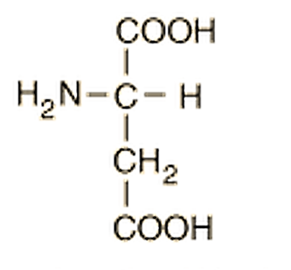
C₄H₇NO₄
Aspartic acid
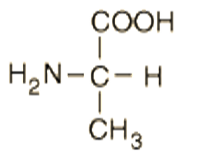
C₃H₇NO₂
Alanine
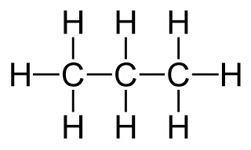
Propane
C₃H₈

Glycolaldehyde
C₂H₆O₂

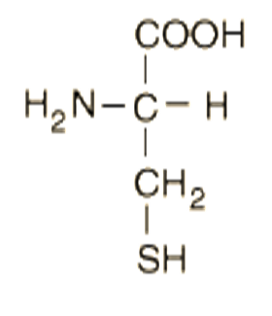
C₃H₇NO₂S
Cysteine
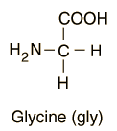
C₂H₅NO₂
Glycine
Adenine
C₅H₅N₅
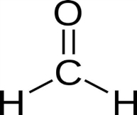
Formaldehyde
CH₂O

C₅H₁₁NO₂S
Methionine

Fatty Acid
CH₃(CH₂)₁₀COOH

1) Examine the molecules produced in the Abiogenesis experiments. Categorize their importance to life into the chart below based on the structure of each. Be sure to draw and label the molecule in each appropriate column.
*Hints have been inserted into each column to help you.

Carbohydrates  (C_{x}H₂O_{x}) | Lipids  (Hydrocarbons: C backbone bonded to many H’s) | Proteins  (Amino Acids: Central Carbon bonded to H, NH2, COOH and variable group) | Nucleic Acids  (Nitrogenous bases: purines- double C & N ring, Pyrimidines- single C & N ring)

2) Why were these molecules so important to the formation of life?
Importance to Life
Carbohydrates
Lipids
Proteins
Nucleic Acids

The inorganic molecules present in the Miller-Urey laboratory atmosphere (H₂O, H₂, CH_{4,} NH₃), are shown below.

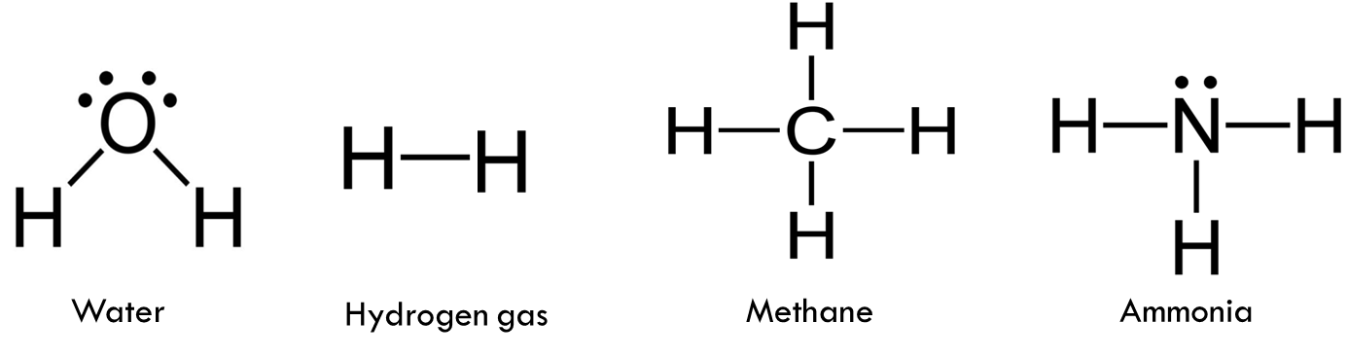

3) Examine the chart “Biomolecules Produced by Abiogenesis Experiments” and determine for each molecule listed which molecules in Miller’s laboratory atmosphere would have come together to create these biomolecules.

Biomolecule Produced | Possible Inorganic Molecules Needed to Build Biomolecule

Some evidence suggests that Earth's original atmosphere may have differed from the one proposed by the Urey Miller Experiment. There is abundant evidence of major volcanic eruptions 4 billion years ago, which would have released carbon dioxide (CO₂), nitrogen (N), hydrogen sulfide (H₂S), and sulfur dioxide (SO₂) into the atmosphere. Experiments using these gases in addition to the ones in the original Miller–Urey experiment have produced more diverse molecules.

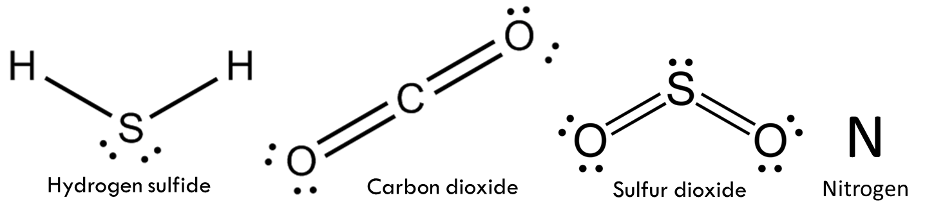

4) Examine the molecules remaining on the “Biomolecules Produced by Abiogenesis Experiments” chart and determine if the molecules available in this revised atmosphere could have played a part in their formation.
Complete the chart for these molecules as before.

Biomolecule Produced | Possible Inorganic Molecules Needed to Build Biomolecule

5) The following are statements about the nature of science. For each, evaluate how the Miller-Urey Experiment as well as later experiments discussed supports these statements.

A) Scientific knowledge is based on empirical evidence, and is appropriate for understanding the natural world, but it provides only a limited understanding of the supernatural, aesthetic, or other ways of knowing, such as art, philosophy, or religion.

B) Scientific knowledge is durable and robust, but open to change.

