Water, Water Everywhere – But How Does it Sustain Life?
Instructor Version
Objectives
- Description of the structure of water molecules
- Description of intra and inter molecular bonds of water and other molecules
- Discussion of the 4 unique properties of water making it crucial for life on earth
- Discussion and review of chemical bonding & electronegativity

Next Generation Sunshine State Standard
- SC.912.L.18.12 Discuss the special properties of water that contribute to Earth’s suitability as an environment for life: cohesive behavior, ability to moderate temperature, expansion upon freezing, and versatility as a solvent.

Student Materials/Equipment
- 3D Molecular Designs Water Kit – (each kit includes 12 water molecules (24 red pieces & 24 white pieces), 1 sodium (smaller blue atom), 1 chloride (larger green atom), 1 ethane, and 1 hydroxyl group (an oxygen and hydrogen molecule - OH)
- NaCl Lattice Kit
- Molecular Twister Kit
- Activity sheet – Water, Water Everywhere – But How Does it Sustain Life?
-Instructor version – includes answers to guided questions and addition resources and tips
-Student version – can be given directly out the to the students as an activity

Teacher Materials/Equipment
In addition to the water kit, molecular twister kit, and the student activity sheet, the provided power point presentation and instructor guide could be used to coach the students through the activity at certain points in the power point. It is includes activity sheet answers (which are underlined in the instructor version) and tips for running the activity. For the Molecular Twister Kit, this document will guide you to the provided documentation for the Molecular Twister Kit which includes descriptions and instructions for the activities utilizing that specific kit.

Instructions for 3D Water Kits
Each unassembled water molecule has two red and two white pieces. When snapped together, the two red pieces represent the one oxygen atom in H₂O. Each white piece represents one of the hydrogens in H₂O. The sodium (blue atom) and chloride (green atom) ions, when bonded together, represent table salt. Six magnets are embedded in each. The positive poles of the magnets in the sodium attract the negative poles of the magnets in the oxygen. The negative magnets in the chloride attract the positive magnets in the hydrogen. There are additional Na and Cl ions found in the NaCl lattice kit that can be used to simulate NaCl and the dissolving of table salt in water. There is an ethane molecule (CH3CH3) which consists of two gray carbon atoms with three white hydrogen atoms on each carbon. The hydroxyl group consists of one red oxygen atom and one hydrogen atom. The hydroxyl group is a functional term. We refer to the hydroxyl group in our materials when talking about the partially charged part (oxygen and hydrogen) of the ethanol molecule. The ethane has no embedded magnets, since it is nonpolar. The hydroxyl group has two negative magnets embedded in the oxygen and one positive magnet embedded in the hydrogen. All of the atoms in the ethane and hydroxyl group are permanently attached and can’t be taken apart with one exception. One of ethane’s hydrogen atoms is attached with a post and can be removed and replaced with the hydroxyl group. By doing so, the ethane becomes ethanol (CH3CH2OH) – a polar molecule. Some of the activities and instructions in this document are taken directly from the 3D Molecular Designs Water Kit resources page.
Information about magnets in the molecules
The magnets are in each piece to help us see and feel how water molecules “stick” together.
Water molecules are able to stick together because they are polar. While the magnets help us represent polarity in these models of water molecules, polarity is not magnetic. Misconception Caution - Although the use of magnets to represent the partial positive and negative charges that exist on the hydrogen and oxygen atoms of water is a powerful teaching tool, it is important to explain to students that atoms are not magnets. To relay this to the students, you can ask your students to assemble the water molecules, tell them to locate the embedded magnet in each piece, and then explain the misconception above.

Procedures
The students can do this activity sheet in groups of your designation in the specified prompts during the power point presentation. Students can answer questions on the activity sheet, but the instructor can also use whiteboards or clickers (depending on classroom resources) as a real time assessment for some of the questions. This activity can be modified as you see fit in your classroom. Multiple standards are addressed and reviewed. The activity sheet can be used in parts as topics are introduced or as a review after all topics have been presented.

The guided activity has been separated into 5 distinct sections to be used together or separately in a continuous activity or as separate activities when topics are introduced. Section 6 are challenge questions based on an environmental or health premise that can be used in conjunction with the presented activity as the teacher sees fit for their individual classroom.
Part 1 – Structure of Water – 3D Water Kit
Part 2 – Electronegativity & Bonding
A) Electronegativity – Molecular Twister Kit
B) Bonding – Molecular Twister Kit
C) Bonds within the water molecule – 3D Water Kit
Part 3 – Polarity of Water – 3D Water Kit
A) Bonds between water molecules
B) Bonds between water molecules & other molecules including
(a) Ethane & Ethanol
(b) NaCl
Part 4 – Unique Properties of Water – 3D Water Kit
A) Cohesion & Adhesion
B) High Specific Heat Capacity
C) Expansion Upon Freezing
D) Versatility as a Solvent
Part 5 – Role of pH Changes – Molecular Twister Kit
Part 6 – Challenge Questions – Molecular Twister Kit

Water, Water Everywhere – But How Does it Sustain Life?

Water is everywhere – you drink it, you swim in it, you perspire it, and it sustains life on Earth as we know it. Do you know how a water molecule can do all that? Do you REALLY understand what you are drinking and swimming in? Why is everything usually dissolved in water – how does your sugar dissolve in your coffee? To understand how water is so essential to life, we need to understand the water molecule’s structure on a molecular level and investigate how water interacts with other substances in the environment. It doesn’t sound fun I know, but we are giving you a 3D Water Modeling Kit complete with magnetized water molecules and a Molecular Twister Kit complete with a hat made up of electrons to help you visualize these molecules and make it more fun in the process. Enjoy a drop or two of water!

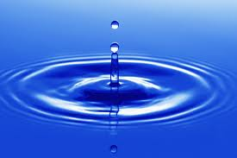

Part 1) Structure of Water

Let’s start by assembling several 3D water molecules that are large enough to see using the 3D Water Kit.

1) Using Figure 1 below, please answer the following questions. One water molecule is made from 1 atom of __oxygen________________ and 2 atoms of ____hydrogen______________ for the chemical formula of water written as ___H₂O___________.
There should be a number and 2 letters in your last answer of the chemical formula of water.
2) What does the number between the 2 letters represent? When a number is placed after a letter, it means there is more than one atom of that element and when there is no number after a letter, it means there is only one atom of that element.

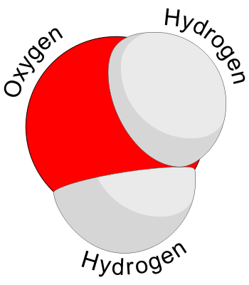
Figure 1

Activity – Assemble 12 water molecules using the 3D Water Kit.
Instructions:
-Select two red oxygen pieces and two white hydrogen pieces.
-Take one red piece in each hand. You will see one post and one hole on the inside rim of each red piece.
-Position the post of one piece into the hole of the other piece.
-Place your thumbs on the flat surface of each oxygen piece and push the two pieces together until they fit tightly and you no longer see a space between the pieces.
-The red oxygen atom will now roughly resemble a sphere with two knobs sticking out of
each half.
-Take the red oxygen atom in one hand and one white hydrogen piece in the other
-Place the open side of the hydrogen piece onto the knob on the oxygen. Push the two together until the hydrogen fits tightly onto the oxygen, with no space between the two pieces.
-Repeat with a second white hydrogen piece.
-You now have one complete water molecule.
-Repeat steps until 12 water molecules are assembled.

Look at your assembled water molecules.
3) What element is the red ball? _oxygen____ and what element is the white ball? Hydrogen.

4) Draw and label a water molecule below with the name of each atom:

Hydrogen
Hydrogen

+
+

- -

Oxygen

Part 2) Electronegativity & Bonding

A) Electronegativity – Activities associated with the Molecular Twister Kits so please refer to that document.

Briefly, due the chemistry of valence electrons, some elements are more electronegative than others. The most electronegative elements are shown in Figure 2 as orange with the values closest to 4.0.

1) Looking at Figure 2 below, which element is MORE electronegative, oxygen or hydrogen? ___oxygen____________

When sharing electrons, an element that is MORE electronegative will have the electrons in their shells more often than the element that is less electronegative.

2) Between hydrogen and oxygen, which element will have the electrons in their shell more often? Oxygen_____

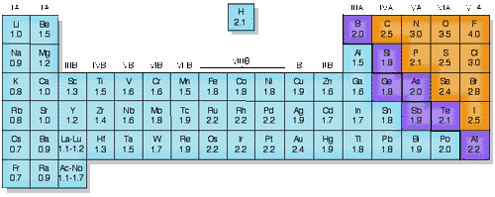

ENTable.gif faculty.sdmiramar.edu
Figure 2

Electronegativity can be hard to relate to sometimes so let’s relate electronegativity to a Tug of War!

You signed up for a Tug of War contest and can win $1000. It is your turn. They call your name, you grab the rope, and then they call your opponents name. He steps up to grab the rope. You turn to look and see the gentleman in Figure 3. That $1000 is not looking so good now!

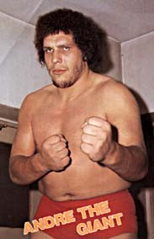
gunnston.com
Figure 3

Think about two elements having a tug of war when they share electrons. When two elements share electrons, no one really wins the contest. The knot or flag in the middle of the rope isn’t pulled all the way to one side or the other but does spend more time on one side than the other.

3) The knot will spend more time on the side of ____Andre the Giant___ (answer Andre the Giant or you). In this example, Andre the Giant is most like ___oxygen___ (answer oxygen or hydrogen).

In this example, Andre the Giant might actually win the Tug of War competition and in that case the knot will be taken by Andre. This is analogous to electrons being “stolen” from one element to another, which is no longer considered sharing electrons.

We will relate this to the types of bonds being formed between elements in Part 2B.

Please refer to the Molecular Twister Kit for activities related to this Part.

B) Bonding – Activity – Activities associated with the Molecular Twister Kit

1) A covalent bond is formed when two atoms share two electrons. A covalent bond is an intra molecular bond within one molecule. Covalent bonds can be either polar (which have partially charged atoms) or nonpolar (without charged atoms) due to unequal sharing of electrons. This is analogous to no one winning the Tug of War contest, but the knot possibly moving to one side or the other.

2) A hydrogen bond is an intermolecular force between the two molecules where a positively charged hydrogen atom interacts with a negatively charged fluorine, nitrogen or oxygen atom in a second molecule.

3) An ionic bond is the complete transfer of an electron between two atoms resulting in one positively and one negatively charge atom. Ionic bonds are intra molecular bonds within one molecule. This is analogous to Andre the Giant winning the Tug of War contest and pulling the knot and you all over to his side.

4) Ions are charged atoms that have gained or lost electrons as a result of an ionic bond.

C) Bonds within the water molecule
Refer to Figure 1 above.
1) The bond between the red oxygen and the white hydrogen molecule is called a ___covalent_____________ bond. This bonds is when the oxygen and hydrogen atoms __share_______ their electrons.

Activity – 3D Water Kit
Instructions:
-Take 1 water molecule from your kit
2) Where is the covalent bond is located. Between the red oxygen and white hydrogen molecule
-Try to pull apart that covalent bond by pulling a hydrogen atom off the water molecule.
-You might have to use your fingernails to pry it apart!

3) Was that easy? No
4) Would you call that a strong or weak bond? Strong

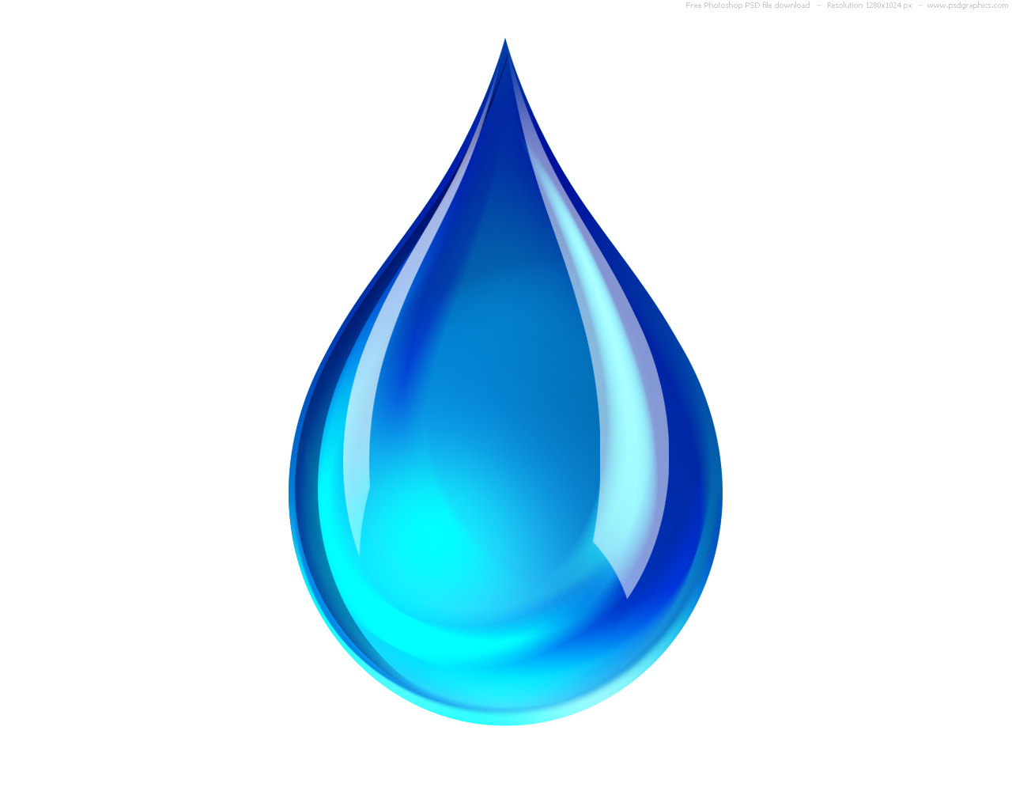Water fact – A hydrogen bond is about 1/20 as strong as a covalent bond.

Part 3) Polarity of Water

Instructor Information on Water Kit:
The water molecules in the Water Kit have been embedded with magnets to help students experience what the (+) and (-) charges feel like as they interact with other polar molecules. Through manipulation of 3D Water, it becomes easy for students to understand many of the physical and chemical properties of water. There are two magnets embedded in the oxygen at 105º degrees from each other. These represent the two partial negative (-) charges. One magnet in each of the hydrogen atoms represents the partial positive (+) charges. The hydrogen molecules are also positioned 105º degrees apart. The location of these four magnets (charges) makes it possible for your students to create a “tetrahedral” structure. A tetrahedral structure is formed when one water molecule interacts with four other water molecules.

Water had unique characteristics in part due to the fact the oxygen and hydrogen atoms in 1 water molecule do not share electrons equally. This leads to what we call polarity.

Remember our Tug of War analogy!

1) Who will likely with the Tug of War? ____Andre the Giant____________ .
2) Remember, Andre the Giant is analogous to the element oxygen in a water molecule. Therefore, electrons are shared more with oxygen than they are with hydrogen.
3) Since electrons are _negatively__ (indicate positively or negatively) charged, the atom that holds the electrons more tightly are __negatively_________ charged, while the atom that holds the electrons less tightly are positively charged.

4) For a water molecule, oxygen will have a partial negative charge while hydrogen will have a partial positive charge.

Polarity refers to the partial positive charge (+) and partial negative charge (-) that a molecule has when electrons are unequally shared between two or more atoms. Molecules that have partial charges are polar molecules. Water molecules are polar molecules. Some molecules do not have unequal regions of charges and therefore do not interact with polar molecules. These are nonpolar molecules. Oil and ethane are examples of a liquid and a gas composed of nonpolar molecules.

5) On your water molecule drawn in Part 1, question # 4, draw the partial positive and negative charges on the correct elements. Think about how many charges will be on each atom.
A + symbol will be drawn on each hydrogen and two – symbols will be drawn on the oxygen.

6) Each hydrogen has ___1_____ (indicate a number) _____positive________ (indicate positive or negative) charges and the oxygen has ____2_____ (indicate a number) ___negative__________ (indicate positive or negative) charges.

A) Bonds between water molecules

Does a water molecule exist in a glass of water alone? Of course not! How many water molecules do you think are in a single drop of water? How does that water droplet stay together when it falls?

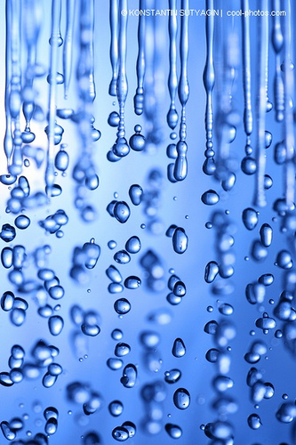
www.flickr.com
Figure 4

1) Can you see with the naked eye a single molecule of water? No
2) Can you see with the naked eye a single drop of water? Yes

Water fact – There are 3 x 10²¹ of molecules in one drop of water (3,000,000,000,000,000,000,000). This number is read, “three times ten to the twenty first power.

Water fact - Just for comparison, a “water drop” made of 3 x 10²¹ of 3D Water Molecules would be larger than the earth.

3) Predict what will think happens when two water molecules bump into each other?
The partial charges on the oxygen and hydrogen molecules will attract with each other and “stick” together

Activity – Interaction between water molecules – 3D Water Kit
-Hold 2 water molecules up (one in each hand)
-Try to join the 2 oxygen (red) molecules together.
4) What will happen when the oxygen atoms of 2 different water molecules come together? They repel.
5) Why does this happen? ___because they are the same charges, both negative
-Try to join the 2 hydrogen (white) molecules together.
6) What will happen when the hydrogen atoms of 2 different water molecules come together? They repel.
7) Why? ___because they are the same charges, both positive
-Join an oxygen (red) molecule from one water to a hydrogen (white) from another water.
8) What will happen when an oxygen atom and a hydrogen atom from two different water molecules come together? They attract.
9) Why? ___because they are different charges, hydrogens are positive and oxygens are negative
-Hold 1 water molecule up.
-Try to bind as many water molecules as you can to that central water molecule.
10) How many water molecules can bond to each oxygen? 2___
11) How many water molecules can bond to each hydrogen? 2___
12) What is this bond called? Hydrogen bonds
-You have just made a tetrahedral structure
13) How many water molecules total can bind to 1 water molecule? 4___
14) What are those 4 bonds called? ____hydrogen bonds___________
-On the picture below, Figure 5, write what type of bond it is next to the black lines.

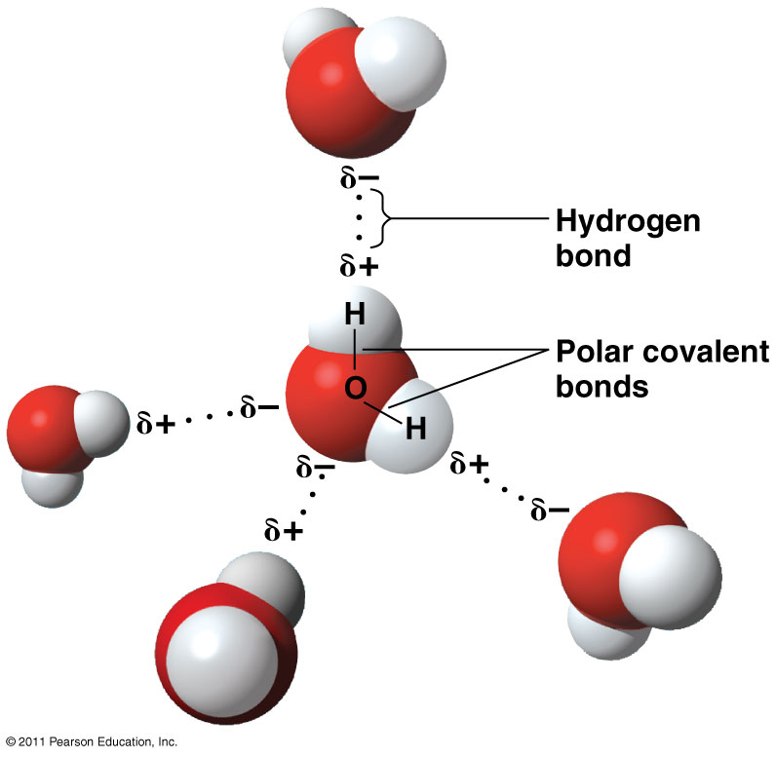
Figure 5

15) The bond __covalent___answered in the center water molecule is called an intramolecular bond because it is within 1 water molecule.
16) The bond __hydrogen ______ answered in the top line is called an intermolecular bond because it is between 2 water molecules.
-Now let’s try to break the bonds.
-Try to pull apart the water molecules
17) How did this compare to the activity in Part 1 when you tried to pull the hydrogen away from an oxygen atom in a single water molecule? It is much easier.
-So you remember how you had to use a fingernail to pry the hydrogen off the oxygen/
18) Which bond is stronger? Covalent bond

19) Now, let’s review:
What is the intermolecular force that holds these two water molecules together? Hydrogen bonding. What is the intramolecular bond that holds the hydrogen atoms and oxygen atom within a water molecule? Covalent bonds. Is a water molecule a polar covalent molecule, or a nonpolar covalent molecule? Why? Water molecules are polar covalent molecules because electrons are shared within the molecule and the sharing of the electrons is unequal which results in partially positively charged hydrogen atoms and a partially negatively charged oxygen atom.

B) Bonds Between Water & Other Molecules

Water doesn’t exist in nature only with other water molecules. Water interacts with many other types of molecules such as salt, sugar, alcohol, and so on. How water interacts with these other molecules is important in understanding different properties of water and how it serves to sustain life. Also, it explains why that sugar dissolves so nicely in your coffee!

a) Ethane & Ethanol

Ethane & Ethanol creation for teachers. In addition to the red oxygen and the white hydrogen pieces (with magnets) in each Water Kit cup, you’ll find these additional pieces – two gray carbon pieces, one hydroxyl (red oxygen with white hydrogen attached to it) and six white hydrogen pieces with a gray post packed in a zipbag. The six hydrogen are bagged to separate them from the other hydrogen in your kit because, the hydrogen that attach tot eh carbon to form ethane don’t have embedded magnets.
Instructions to create ethane & ethanol. Take one of the white hydrogen pieces (without a magnet) and the gray post and firmly insert the post into the center hole in the hydrogen. Push until securely in place. Set aside until the rest of the ethane is nearly assembled. Select one of the gray carbon pieces and fold its three petals together until it is completely closed. Place one of the white hydrogen (without a magnet) over one of the knobs on the carbon. Press together until the hydrogen is securely attached. Repeat with two other while hydrogen. All three knobs on the carbon should now have a hydrogen attached. Turn the carbon until you see the hole on one side. Take the unfolded carbon and press the petals together as you did before. Insert one of the knobs in this carbon into the hole of the carbon with the attached hydrogen. Take one of the remaining hydrogen (without a magnet) and push it onto one of the exposed knobs. Repeat with the last hydrogen and knob. Place the hydrogen with the post into the exposed hole to complete the ethane. Note the tiny triangles around the outer edges of this hydrogen. To change the ethane to ethanol, remove the hydrogen surrounded by these triangles. Once the hydrogen and post are removed, insert the hydroxyl (red oxygen with one attached hydrogen) into the hole.

Ethane is a short hydrocarbon molecule. Hydrocarbons are combinations of carbon and hydrogen atoms. Ethane is an odorless, colorless gas that can be used as a fuel, a freezing agent, and in making other chemicals. Ethanol is an alcohol, which means one of the hydrogen groups of ethane is replaced by a hydroxyl group (an oxygen with a hydrogen). It is found in alcoholic beverages and used as a solvent and fuel.

Activity – 3D Water Molecule Kit – Ethane & Ethanol
-Each group of students is given an ethane molecule.
1) What do the different colors on the ethane molecule represent? What is the chemical formula of ethane? White represents hydrogen atoms and the gray represents carbon. CH3CH3
.
2) What is the intramolecular bond that holds the hydrogen and carbon atoms together within an ethane molecule? Covalent bonds.
-Try to stick a water molecule onto ethane.
3) Can you make the water molecule stick to ethane? No

4) Is an ethane molecule a polar covalent molecule, or a nonpolar covalent molecule? Why?
Ethane molecules are nonpolar covalent molecules because electrons are equally shared within the molecule. This equally charged molecule is nonpolar. The polar water molecule will not stick to the nonpolar water molecule.

5) Will ethane form a hydrogen bond with water? Why or why not?
No, ethane will not form a hydrogen bond, or ionic bond with water or any other polar molecule because it is nonpolar. Ethane does not have any partial positive or negative charges.

-Get together with another group and try to stick 2 ethane molecules together.
6) Will two ethane molecules form bonds with each other? Why or why not?
No. Ethane molecules will not form covalent, ionic or hydrogen bonds with each other. They have nonpolar covalent bonds between their atoms.

-Give each student group an OH group (red oxygen & white hydrogen) and have them replace the detachable hydrogen on the ethane with the OH group.
7) You have just changed the molecule from ethane to ethanol.

8) What do the different colors represent? White represents hydrogen atoms, the gray represents carbon atoms, and the red represents oxygen atoms.

9) What is the chemical formula of ethanol? CH3CH2OH.

-Pick up an ethanol molecule and a water molecule and try to stick them together.
10) Will ethanol and water interact? How?
Yes, The water molecules will form hydrogen bonds with its oxygen atom and the single polar hydrogen atom on the hydroxyl of ethanol.

-Get together with another group and try to stick your 2 ethanol molecules together.
11) Will ethanol molecules interact with each other? Why & How?
Yes. Ethanol will form hydrogen bonds with other ethanol molecules between the oxygen of 1 ethanol and the hydrogen of the other ethanol due to the polar covalent bonds between oxygen and hydrogen cause partial charges and thus attractions.

-Between your 2 groups, only 1 of the groups change the ethanol back to ethane (remove hydroxyl group and replace with hydrogen)
-Try to stick together ethane and ethanol molecules.
12) Will ethanol and ethane interact? Why or why not?
No, ethane only contains nonpolar covalent bonds so no partial charges in that molecule and thus no attraction between ethane and ethanol.

13) The bonds between the water molecules and the OH group on the ethanol are called hydrogen bonds. Water molecules and ethanol molecules are polar covalent molecules while the ethane is a nonpolar covalent molecule. (answer with polar or nonpolar)

b) Table Salt - NaCl

Ionic bonds are formed between the sodium and chloride ions. This is an intramolecular bond.
The attraction between the negatively charged 3D Water Molecule and the positively charged sodium ion (from the sodium chloride molecule) is an intermolecular force. Partially positively charged hydrogen atoms (see water and ethanol molecules) will interact with negatively charged chloride ions. This is not called a hydrogen bond because the chloride ion is not one of the three elements involved in hydrogen bonding (fluorine, nitrogen or oxygen). This is another type of
intermolecular force.
Teacher instructions with the kit - The Water Kit© comes with a blue sodium (Na) ion and a green chloride (Cl) ion. These two ions form an ionic bond to make sodium chloride (NaCl), often called table salt. When water dissociates sodium chloride, the hydrogen atom interacts with the negatively charged chloride ion and the oxygen atom interacts with the positively charged sodium ion.

Add salt to water and what happens? It dissolves, right? How does this happen? What exactly is table salt?

Review:
1) Ions are charged atoms that have gained or lost electrons as a result of an ionic bond.
2) This ionic bond that holds these ions together is an intramolecular bond. What does this mean? Ionic bonds are formed when an electron is completely transferred from one atom to another. This results in a positively charged ion (the atom that loses an electron) and a negatively charged ion (the atom that gains an electron).

Activity – 3D Water Activity Kit - NaCl
-Take a blue circle in one hand. This is a sodium ion.
3) Sodium Ions have a ___positive__________ charge due to loss of an electron.
4) The chemical symbol for sodium is Na.
-Take a green circle in one hand. This is a chloride ion.
5) Chloride Ions have a ___negative__________ charge due to gain of an electron.
6) The chemical symbol for sodium is Cl.
-Try to put the sodium and chloride ions together.
7) What happens? The two molecules bond or stick together.
8) Why? Sodium ion has a positive (+) charge and chloride has a (-) negative charge so they are attracted to each other.
9) What type of bond is formed? They form an ionic bond.
10) What is the chemical formula for this? What is the compound? NaCl. NaCl is often called table salt.

Now let’s see how salt dissolves in water!
-Obtain twelve 3D Water Molecules and a tray.
-Place the sodium chloride in the center of the tray and the 3D Water Molecules along the edges
-Gently shake the tray.
11) What happened? The water started surrounding and binding to the NaCl molecule in the center.
-Pick up the NaCl from the tray.
12) What comes with it? All the water molecules
13) What happens when you put salt in a cup of water? It dissolves. Water molecules surround the entire sodium and chloride, breaking them apart.
-Look at the blue sodium ion on the tray.
14) What atoms from water are binding to it? Oxygen
15) Why? What charges do each molecule have? The sodium, a positively charged ion, is attracted to the oxygen of a water molecule due to the partially negative charge on oxygen in a water molecule.
-Look at the green chloride ion on the tray.
16) What atoms from water are binding to it? Hydrogen
17) Why? What charges do each molecule have? The chloride, a negatively charged ion, is attracted to the hydrogen of the water molecule due to the partially positive charge on hydrogen in a water molecule..
18) What happens when you keep adding salt to a glass of water? Why does this happen?
Eventually, salt begins to form at the bottom of the glass when there are not enough water molecules to surround the salt.
19) What is this called? This is a supersaturated solution.
20) What happens to a glass of salty water when it is heated to boiling? The water evaporates leaving the sodium and chloride to bond to form salt again.
21) The bond between a water molecule and a sodium chloride is an intermolecular force. (answer inter or intra molecular)
22) Do hydrogen atoms and chloride ions form hydrogen bonds? Why? No, the intermolecular force between the hydrogen atom and chloride ion is not a hydrogen bond because hydrogen bonds are only formed between hydrogen and fluorine, nitrogen and oxygen atoms.

Now let’s try that with another molecule!
-Put an ethane molecule in the center of the tray and the 3D Water Molecules along the edge.
-Gently shake the tray.
23) What happened? Water stuck to each other but not to ethane.
-Pick up the ethane molecule from the tray.
24) What comes with it? Nothing
25) Will water dissolve ethane? Why or why not? No. Water cannot dissolve ethane because ethane is nonpolar. Water cannot form hydrogen bonds with ethane.
-Place NaCl and ethane on the tray.
-Gently shake the tray.
26) Will sodium chloride interact with ethane? Why or why not?
Sodium chloride will not interact with ethane because ethane is nonpolar. Sodium chloride will interact with the ethanol.
-Using the kit alter ethane so that it could interact with NaCl?
27) What did you do to the ethane molecule? Added a hydroxyl group to ethane to make it ethanol which will make it polar and now able to interact with NaCl.

28) Let’s Review Bonding Between these Molecules!
-List the words water, ethane, ethanol, sodium and chloride in two columns.
-Draw solid lines between the molecules that will form hydrogen bonds.
-Draw dotted lines between the ions that will form ionic bonds.

Water Water
Ethane Ethane
Ethanol Ethanol
Sodium Sodium
Chloride Chloride

How does a drop of water stay together when it falls from the sky? Why does a paper towel work to dry off water from a table but you can’t use wax paper to do the same? How does a plant get water from the ground? Discussion of these types of questions can occur in the classroom by guiding the students through the Unique Properties of Water that are introduced in Part 4 below. These properties exist due to the molecular interactions and bonds within and amongst water and other molecules that you just learned in Parts 1 to 3 of this activity.

Part 4) Properties of Water
A) Cohesion & Adhesion

Teacher Information:
The attraction between two like molecules is cohesion. The attraction between two unlike molecules is adhesion. Adhesion and cohesion are intermolecular forces between two molecules. These forces are only called hydrogen bonds when a hydrogen atom and a fluorine, nitrogen, or oxygen atom are attracted to each other. Capillary action is the spontaneous rising of a liquid in a capillary (small diameter) tube. Capillary action in plants is a good example of adhesion and cohesion. The inner surface of the xylem, the cell wall of a plant, contains positive and negative charges to which water forms hydrogen bonds. This is called adhesion. As water creeps up the sides of the xylem (adhesion) the water molecules in the middle connect to other water molecules because of cohesion. The water moves up as the water molecules at the top of the xylem enter the leaves and evaporate (move out of the stomata in the leaf). When a water molecule leaves the leaf, the molecule behind it moves up causing a general movement of the water up the tree.

Activity – 3D Water Kits - Cohesion & Adhesion
Teachers – require dental floss or fishing line
-Tie a string around a 3D Water Molecule.
-Hold the string in one hand and another 3D Water Molecule your other.
-Slowly bring the second 3D Water Molecule toward the one on the string.
1) What happened? The hanging water molecule will move toward the water molecule in your hand and then stick together.
2) What is this type of attraction called? cohesion.
-Next, bring an ethanol molecule toward the hanging 3D Water Molecule.
3) What happened? The hanging water molecule will move toward the ethanol molecule in your hand and then stick together.
4) What is the attraction between these molecules called? The force is called adhesion because two different molecules are attracting.

Water Tip – Adhesion adds a different molecule to the substance.

-Hold the ethanol molecule in the air with a strong.
-Bring a second ethanol molecule toward the first.
5) What happened? The hanging ethanol molecule will move toward the ethanol molecule in your hand and then stick together.
6) What is the attraction between these molecules called?
The force is called cohesion because two like molecules are attracting.

Activity – 3D Water Kits - Capillary action
Teachers – require a magnetic whiteboard, Demonstrate capillary action by drawing a plant on a whiteboard. If your whiteboard is not magnetic, use a quarter section of chimney-stove pipe or a small magnet white message board.

-Draw a plant on a whiteboard
-Place 11 of the 3D Water Molecules at the root of the outlined plant.
-Pull the molecules up the roots, through the stem and out the leaves of your plant with the molecule attached to the string.
7) What happened? Some of the water molecules will bond with the board and some to other water molecules.
8) What is this called? Capillary action

Teachers – You can explain that this is capillary action. Water molecules form hydrogen bonds with cellulose in the xylem. The cellulose is composed of carbon atoms with hydroxyl groups (sugars). In addition, water molecules also form hydrogen bonds with each other.

9) Does capillary action involve adhesion or cohesion? Capillary action involves both adhesion and cohesion. When water molecules are attracted to the xylem (the board), adhesion is involved. When the water molecules are attracted to each other, cohesion is involved.

When you get out of the pool why do you grab a beach towel and not wax paper? How does a beach towel dry you off? It is all due to Cohesion and surface tension! What happens when it rains and you just waxed your car? Maybe you applied Rain-X to your car windshield? What do people do this in Florida?

What is surface tension?
Water molecules are polar and have a relatively strong attraction to each other though bonds called hydrogen bonds. This attraction is responsible for surface tension. Surface tension explains why water forms rounded drops on nonpolar surfaces like the waxy surface of an apple or a recently waxed or Rain-Xed car.

Activity – 3D Water Kit – Surface tension
Teachers – requires other surfaces such as office paper, wax paper (or draw a solid rectangle with crayon on paper to simulate wax paper), paper towels, plant leaves, plastic, fabric,…
-Place drops of water on the provided substances.
-Record the substance and draw the relative height of the drop.
-Draw below what the relative height of the drop on each surface looks like.
10) Which substance provided the largest water bead height?
A nonpolar substance like wax that doesn’t attract polar water molecules

11) Which substance provided the smallest water bead height?
A polar substance like paper towels that attract the water molecules.

12) Why does water bead up on some substances, like wax, and soak into others, like paper? Water does not interact with nonpolar substances. Wax is a nonpolar substance; the water molecules are only being pulled toward each other, forming a sphere. Office paper has a coating which is more polar than wax, but less polar than paper towels. This results in a dome-shaped drop. Paper towels are more polar than office paper. Paper towels actually break the surface tension of water to absorb it.

Can you think of anything that can walk on water? Yes, some insects, like the water strider, can walk on water. Let’s test how this might work!

Activity – 3D Water Kit – Walk on Water!
Teachers – require small toy insect, tray and paperclips
-Pool twelve 3D Water Molecules together on a tray.
-Place a small toy insect on top
-Gently shake the tray.
13) What happened to the insect? The insect will stay on the molecules.
14) What is called? surface tension.
15) Can you explain how an insect does this? The hydrogen bonds are strong enough that certain insects can’t break them and therefore can walk on the water molecules.
16) Why can’t all animals walk on water? Their total mass is sufficient to break the intermolecular force of the hydrogen bonds between water molecules and they sink.

17) What would happen if an insect tried to walk on a nonpolar liquid (molecules that do not have charges)? Record your hypothesis. ________________________________________________________________________ _______________

-Pool several ethane molecules on a tray.
-Place a plastic insect on top
-Gently shake the tray.
18) What happened to the insect? Why? The insect will fall off – break the surface tension and sink. Because there is no surface tension between ethane molecules- they are nonpolar.

19) Why did the insect fall through the surface of the nonpolar molecules? There are no hydrogen bonds (cohesion) between the nonpolar molecules, therefore the insect falls down between the molecules (sinks). While there are weak intermolecular forces between the ethane molecules, they are not strong enough to support the insect.

20) Can you predict what would happen if an insect tried to walk on a slightly polar liquid? ___________________________________________________________________

-Pool several ethanol molecules and on a tray.
-Place a plastic insect on top
-Gently shake the tray.
21) What happened? Results will vary with the weight of the insect and the number of hydrogen bonds formed by the ethanol.

Let’s do this with real liquids!

Activity – Paperclips on Liquid surfaces!
-Teachers – require glasses with water and vegetable oil, fork, and paperclips
-Each group obtains a glass of water and one of vegetable oil, a fork, and several small metal paperclips. The liquids represent 3D Water Molecules (water) and ethane (vegetable oil).

22) Predict what will happen when you lay a paperclip on top of each surface. Why?

-Place a small metal paper clip on the surface of a glass of water.

Note: Students may have to practice this several times before they are successful. Using a fork to place the paperclip on the water can help. Paperclips should be dried thoroughly before trying to place them on a liquid again.

23) What is keeping the paperclip on top of the water? Is it floating? No, the paperclip is not floating. The paperclip is resting on top of the water because the surface tension is stronger than the weight of the paperclip.

-Place a small metal paper clip on the surface of a glass of vegetable oil.
24) What happens? _______________________________________-

B) High Specific heat capacity
Like other compounds, water can convert between solid, liquid, and gas phases. The remarkable property of water is that it is a liquid over a very large temperature range.

Activity – 3D Water Kit – Model the phases!
a) Create a model of the 3 different phases.
- Place 12 water molecules separated on a tray
1) What phase of water is this? Gas
2) Are there hydrogen bonds being formed? Why or Why not? No. In the gas state individual water molecules are moving too fast and are too far apart to form hydrogen bonds.
-Place 12 water molecules clumped together on a tray.
3) What phase of water is this? Liquid
4) Are there hydrogen bonds being formed? How strong are they? Yes. In liquid water, the hydrogen bonds between water molecules are very short-lived. They are constantly forming, breaking, and reforming between other molecules.
-Place 12 water molecules connected in a repeating pattern or formation that form ice on a tray. Challenge them to form an “ice cube,” an enclosed, stable ice lattice. After a few minutes, give students the hint that snowflakes, or ice crystals have six sides – they may want to try rings of six. You can follow the instructions #1 to 7 below. You have now formed an “ice cube.” Ice consists of a repeating pattern of this cube.

5) What phase of water is this? Solid
6) Are there hydrogen bonds being formed? How strong are they? Yes. In ice, the hydrogen bonds between water molecules are more stable and longer-lived.

Scientists have described 12 different structures of ice, many of which can be constructed with the Water Kit©

-To construct Ice 1h, hexagonal ice, follow these directions:
1. Hold one molecule horizontally in front of you (hydrogen atoms pointing to the sides).
2. Add two vertical molecules to the two hydrogen atoms (hydrogen atoms pointing up and down).
3. Add horizontal molecule to the lower hydrogen on each molecule added in step #2.
4. Add one vertical molecule to connect the hydrogen atoms from the molecules added in step#3.
5. Create a second hexagonal ring following steps #1-4.
6. Orient the two hexagonal rings the same way – then rotate one ring 180 degrees.
7. Place one hexagonal ring on top of the other. Do not flip one ring over – the hydrogen on
both rings should point the same direction.

b) Volume of phases of water
-Compare the volume of the twelve water molecules making up the “ice cube” with the volume of the twelve molecules making up the “liquid state”.
7) Which one has more volume? Why? The ice cube takes up a larger volume than the same twelve molecules in the liquid state. This explains why ice floats.
-Place a 13th water molecule into the hole formed by this cube.

Notice that the same volume occupied by 12 water molecules in solid ice, can contain 13 water molecules in its liquid form. Ice has holes, or empty space, in it.

Discussion Questions surrounding phases of water:

8) What are the differences between these groups of molecules? How does their volume differ?
Water vapor, the gaseous state, has the greatest volume. The water vapor condenses to form liquid water. Then the water molecules expand to form the solid form of water, ice.

9) Are these volume changes unique to water?
All gases have greater volumes than liquids. Water, H₂O, is the only compound that expands as it freezes.

10) At room temperature, which substance is a gas and which substance is a liquid? Why?
Ethane is a gas at room temperature because it is a nonpolar molecule which has a weak
intermolecular force. It does not have a partial charge that would attract the molecules to each other. Ethanol is a liquid at room temperature because it is a polar molecule. The OH has a stronger intermolecular force, called hydrogen bonding, which attracts the molecules to each other.

Have you ever tried to walk barefoot on hot sand or black pavement in the summer? What was it like? What did you do? Did you try to walk faster? Keep your feet off the ground somehow? Walk on the grass or go home and put on shoes?

This deals with the concepts of Evaporation & Condensation

Evaporation is the transformation from a liquid to a gas. This occurs when a liquid absorbs enough heat, increasing the movement of the molecules, to cause the intermolecular forces between molecules to break the surface tension. This allows individual molecules to escape into the air. As water evaporates, the heat it absorbs breaks the hydrogen bonds and the liquid water becomes water vapor.

Condensation is the transformation from a gas to a liquid. This occurs when a gas is cooled enough that the molecules slow down to form stronger intermolecular forces with each other. As water condenses, the molecules slow down and form hydrogen bonds with each other as the water vapor cools. Changes in pressure can also influence evaporation and condensation. As pressure increases, gases condense into liquids. As pressure decreases, liquids evaporate as gasses.

Activity – 3D Water Activity Kit – Evaporation & Condensation
-Obtain three 3D Water Molecules to hold between their hands.
-Move your hands together and increase the speed of your hands.
-Rub your hands together to create friction.
11) What happened to the water molecules? They break apart in your hands.
12) What do water molecules do as they heat up? They move faster as well.
13) What type of bonds break in the water molecules? Hydrogen bonds
14) What are you producing with your hands? Heat and/or energy.
15) What is happening to the water molecules (and the hydrogen bonds)?
The molecules are moving around and slowly forming and breaking hydrogen bonds with each other. This represents water in its liquid form.
16) What happens when you heat, or boil, water? It evaporates.
17) What is happening to the water molecules now? The water molecules are moving fast and are not forming hydrogen bonds with each other. This represents evaporation and water in its gas state. To simulate condensation, have your students slow down their hands, drawing heat away from the molecules.

Teachers – remind the students of the breaking of hydrogen bonds in this process.

Activity - Evaporation Activity
Teachers – require rubbing alcohol & a timer
-Place one drop of water and one drop of rubbing alcohol 4 cm apart on their forearms.
-Start a timer.
-Observe and record how what the drops look like and how long it takes to evaporate the drops.
18) What did you observe? The water forms a rounded drop due to its strong surface tension, while the rubbing alcohol flattens. The rubbing alcohol evaporates within 2 minutes. Water takes much longer.

Explain to your students that body heat provides enough energy for the rubbing alcohol molecules to move fast enough to leave the surface of your skin. It takes about 290 cal per gram of rubbing alcohol for the molecules to evaporate, whereas, it takes 580 cal per gram of water to break hydrogen bonds between water molecules (calories are measurements of energy). Your body temperature at rest is not high enough to evaporate water rapidly.

Water Fact – 580 calories of heat are needed to evaporate one gram of water at room temperature.
C) Expansion upon freezing
Water expands as it freezes. Let’s demonstrate this!

Activity – 3D Water Kit
-Form a lattice with 12 molecules and place it in a clear container.
-Measure and record the volume of water in this solid state.
-Gently push down on the molecules to break the hydrogen bonds until all the molecules are at the bottom of the container.
-Measure and record the volume of the molecules in this liquid state.
1) What was your result? Less volume with liquid state than the ice state.

D) Versatility as a solvent
Why are most solutions made with water? Water is used as a universal solvent, but how does it dissolve things? Let’s Dissolve Table Salt with Water Molecules using our Water Kits!

Activity – 3D Water Kit & NaCl Lattice Kit
-Give the students the NaCl lattice.
1) Review: The charge on the sodium (Na) ion is positive and it is the _blue_____color molecule in the lattice. The charge on the chloride (Cl) ion is negative and it is the _green_____color molecule in the lattice.
-Use your created 3D water molecules to dissolve or “pull apart” NaCl. Think about charges on these molecules. Form hydration molecules surrounding NaCl.

2) Which molecule on water pulls apart the chloride ion? Why? Hydrogen because hydrogen has a partial positive charge due to the polar covalent bonds and the chloride ion is negatively charged due to the stealing of electrons. The positive and negative charges are now attracted to each other and thus water can pull apart the chloride ions using the hydrogen of water.

3) Which molecule on water pulls apart the sodium ion? Why? Oxygen because
oxygen has a partial negative charge due to the polar covalent bonds and the sodium ion is positively charged due to the stealing of electrons. The positive and negative charges are now attracted to each other and thus water can pull apart the sodium ions using the oxygen of water.

Part 5) Role of pH changes – Activities associated with Molecular Twister Kits

Part 6) Challenge Questions – Activities associated with Molecular Twister Kits

Additional Activities
Just for Fun
The Water Kit© can be fun as well as educational! Here are some fun activities to do with your students.

Chain of Life
Have students guess how many 3D Water Molecules can be strung on a chain before
the chain breaks. Test their predictions.

Keep Score with Water!
Hang one 3D Water Molecule from the ceiling. As each student correctly answers a water-related question, have them add a molecule to the chain. After enough students have correctly answered questions – and the chain breaks, declare No Homework!

Building with Molecules
Try to build shapes with 3D Water Molecules!
Snowflakes
Pyramid
NaCl

