Geometric Analysis of Muscle Function
How much force does your triceps lever system generate?
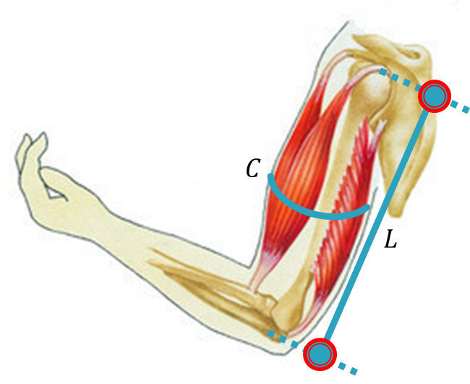 | 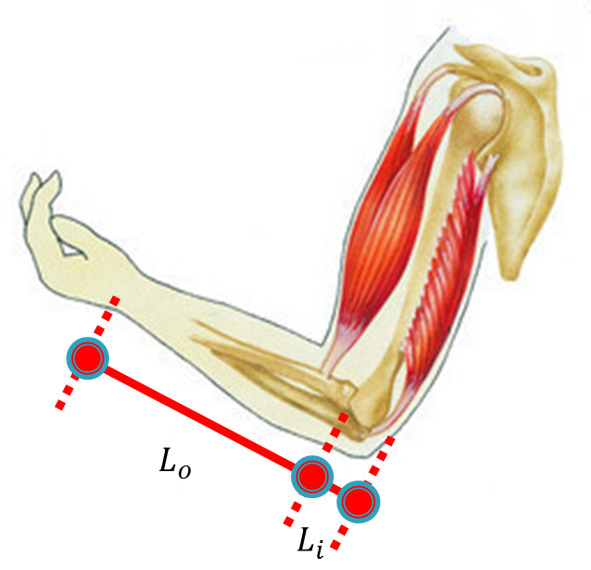

Variable |  | Measured Value | Sample Value
C | Circumference of upper arm |  | 12.25”
L | Length of upper arm from elbow to shoulder |  | 14”
W | Width of tip of elbow |  | 1”
L_{i} | In-lever length (center to tip of elbow) |  | 1”
L_{o} | Out-lever length (center of elbow to wrist) |  | 11”

Variable |  | Calculated Value | Sample Value
R_{t} | Triceps radius |  | 0.975 in
L ÷ 2 | Length of upper arm from elbow to shoulder divided by two |  | 7 in
W ÷ 2 | Width of tip of elbow divided by two |  | 0.5 in
H | Height of full cone |  | 14.37 in
V | Volume of one truncated cone |  | 12.37 in³
V_{t} | Volume of triceps |  | 24.74 in³
FL_{t} | Fiber length of triceps |  | 1.38 in
CSA_{t} | Cross-sectional area of triceps |  | 17.93 in²
T_{s} | Specific tension | 51 lb/in² | 51 lb/in²
Cos 45º | Cosine of fiber angle | 0.7071 | 0.7071
F_{t} | Triceps muscle force |  | 646.6 lb
F_{tls} | Triceps lever system force production |  | 58.78 lb

